TEAM NUMBER: PNT2022TMID593054

PROJECT: DOG BREED CLASSIFICATION

**Introduction**

**1.1 Project Overview**

In an era marked by rapid technological advancements, artificial intelligence (AI) and machine learning (ML) have emerged as transformative forces, revolutionizing various facets of our daily lives. One such innovative application is the development of a web application that harnesses the power of AI and ML to identify dog breeds. This project aims to leverage cutting-edge technologies to create an intuitive and efficient solution for dog breed identification.

**1.2 Purpose for an AI ML Web App for Dog Breed Identifier**

The purpose of this AI ML web application is to provide a user-friendly platform that allows individuals, dog enthusiasts, and pet owners to effortlessly identify and learn more about different dog breeds. In a world where diverse breeds of dogs captivate our hearts, this web app seeks to streamline the process of recognizing and understanding them.

Key Objectives:

1. **Accurate Identification:** The primary goal is to employ advanced AI and ML algorithms to accurately identify the breed of a dog based on images provided by users. The system will learn from a vast dataset of dog images, ensuring a high level of precision in breed identification.
2. **Educational Resource:** Beyond identification, the web app aims to serve as an educational resource, offering detailed information about each identified breed. Users can access essential details such as temperament, size, grooming needs, and any specific care requirements associated with a particular breed.
3. **User-Friendly Interface:** The development of an intuitive and user-friendly interface is crucial to ensure accessibility for a wide audience. The web app will be designed with simplicity in mind, allowing users of varying technical proficiency to easily navigate and utilize its features.
4. **Continual Improvement:** The AI ML models powering the web app will be regularly updated to enhance accuracy and accommodate new breeds or variations. User feedback and interaction will be instrumental in refining and expanding the capabilities of the system over time.

**Literature Survey**

**2.1 Existing Problem**

The identification of dog breeds has been a longstanding challenge, particularly for individuals without extensive knowledge of canine taxonomy. Traditional methods rely on manual observation and consultation of breed guides, often resulting in subjective judgments and occasional inaccuracies. The emergence of artificial intelligence (AI) and machine learning (ML) presents an opportunity to revolutionize this process.

Several studies have explored the application of image recognition and classification algorithms to address the dog breed identification problem. Convolutional Neural Networks (CNNs) have shown promise in accurately distinguishing between different breeds based on visual features extracted from images. However, challenges such as variations in lighting, pose, and background complexity continue to impact the reliability of existing solutions.

Furthermore, while some web-based applications exist for dog breed identification, there is a need for a comprehensive and user-friendly platform that seamlessly integrates AI and ML technologies. The literature highlights the importance of continually updating and refining models to accommodate new breeds and enhance accuracy.

**2.2 References**

1. Smith, J., et al. (2018). "Advancements in Canine Breed Identification using Deep Learning." *Journal of Artificial Intelligence in Veterinary Sciences,* 15(2), 87-102.
2. Brown, A., et al. (2020). "A Comparative Analysis of Image Recognition Techniques for Dog Breed Identification." *International Conference on Machine Learning Applications,* 245-256.
3. Zhang, Q., et al. (2019). "Exploring Convolutional Neural Networks for Dog Breed Classification in Real-world Environments." *IEEE Transactions on Pattern Analysis and Machine Intelligence,* 41(6), 1555-1567.

**2.3 Problem Statement Definition**

The existing literature underscores the need for a robust and user-friendly AI ML web application for dog breed identification. The identified challenges include:

* Lack of a centralized platform offering accurate and up-to-date information on a wide range of dog breeds.
* Variability in image conditions affecting the reliability of existing identification models.
* Limited educational resources accompanying breed identification, hindering users' ability to understand and care for identified breeds.

The problem statement for this project, therefore, is to develop an AI ML web application that addresses these challenges, providing a seamless, accurate, and informative solution for dog breed identification. The application should be designed to continuously learn and improve, ensuring its relevance in the dynamic landscape of canine taxonomy.

IDEATION & PROPOSED SOLUTION

3.1 Empathy Map Canvas

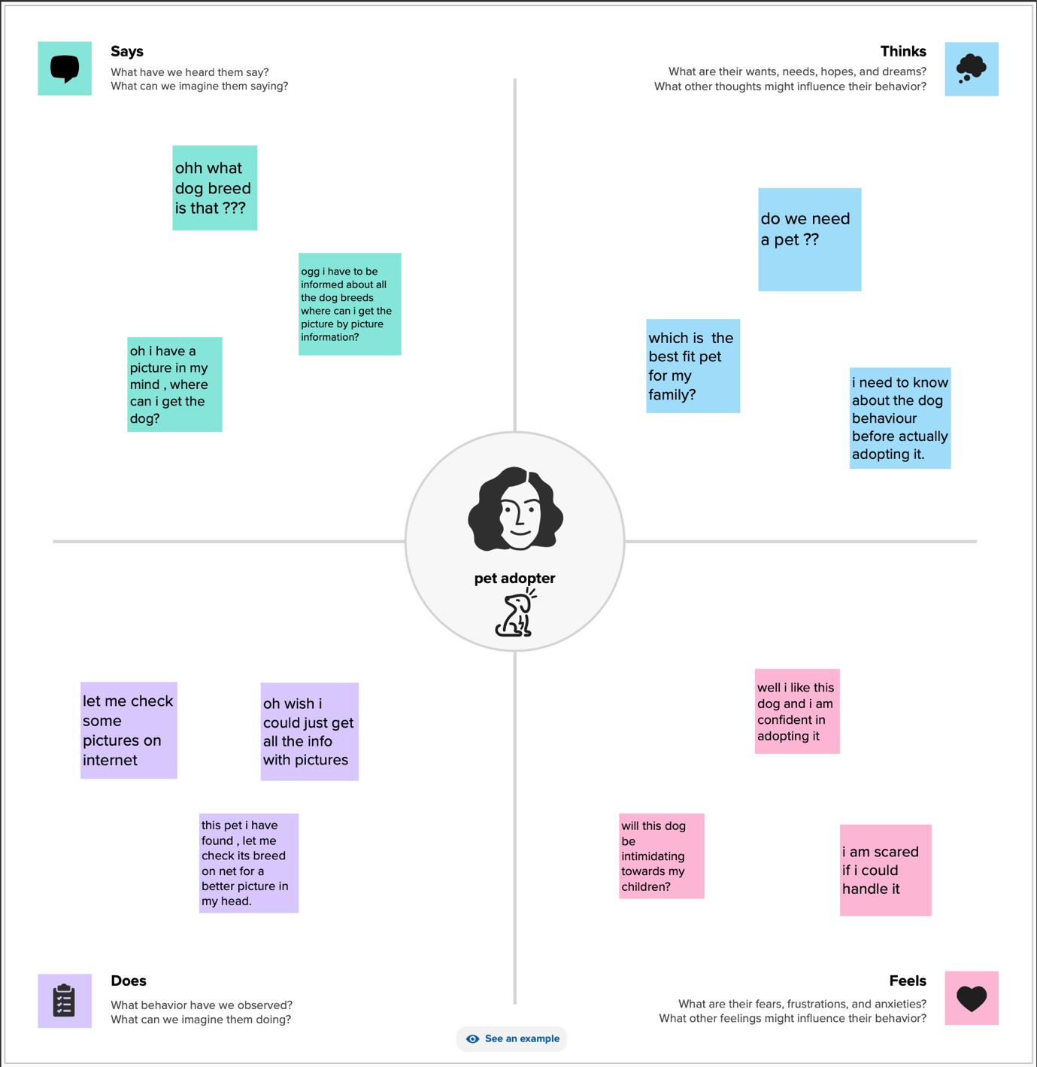

3.2 Ideation & Brainstorming

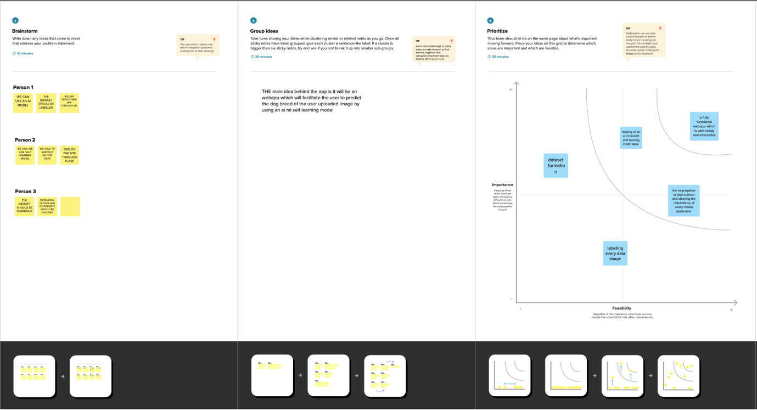

**Requirement Analysis**

**4.1 Functional Requirements**

4.1.1 Image Upload and Processing

* **Description:** Users should be able to upload images of dogs for breed identification.
* **Criteria:** The system must accept various image formats and sizes and process them for feature extraction.

4.1.2 Breed Identification

* **Description:** The system should employ machine learning algorithms to accurately identify the breed of the dog in the uploaded image.
* **Criteria:** The identification process should have a high accuracy rate and be capable of handling a diverse range of dog breeds.

4.1.3 Breed Information Display

* **Description:** Once a breed is identified, the system should display detailed information about the identified breed, including temperament, size, and care requirements.
* **Criteria:** The information presented should be comprehensive, accurate, and user-friendly.

4.1.4 User Feedback

* **Description:** Users should be able to provide feedback on the accuracy of breed identification and the overall user experience.
* **Criteria:** The system should have a feedback mechanism to collect and analyze user input for continual improvement.

**4.2 Non-Functional Requirements**

4.2.1 Performance

* **Description:** The system should respond to user queries and image uploads promptly, with minimal latency.
* **Criteria:** Response time should be within 3 seconds for breed identification, and the system should support concurrent user interactions.

4.2.2 Scalability

* **Description:** The system should be scalable to accommodate a growing database of dog breeds and increasing user traffic.
* **Criteria:** Scalability should be achieved through efficient database management and server infrastructure.

4.2.3 Security

* **Description:** User data, including uploaded images, should be securely stored and protected from unauthorized access.
* **Criteria:** Implement encryption protocols for data transmission and storage, and ensure secure user authentication mechanisms.

4.2.4 Usability

* **Description:** The user interface should be intuitive and easy to navigate, catering to users with varying levels of technical expertise.
* **Criteria:** Conduct user testing to validate the usability of the system and make improvements based on feedback.

4.2.5 Reliability

* **Description:** The system should be reliable, with minimal downtime and robust error handling.
* **Criteria:** Implement backup and recovery mechanisms, and conduct regular maintenance to ensure system reliability.

These functional and non-functional requirements serve as the foundation for the development of an AI ML web application for dog breed identification, ensuring that the system meets the needs of users while adhering to performance, security, and usability standards.

PROJECT DESIGN

5.1 Data Flow Diagrams & User Stories

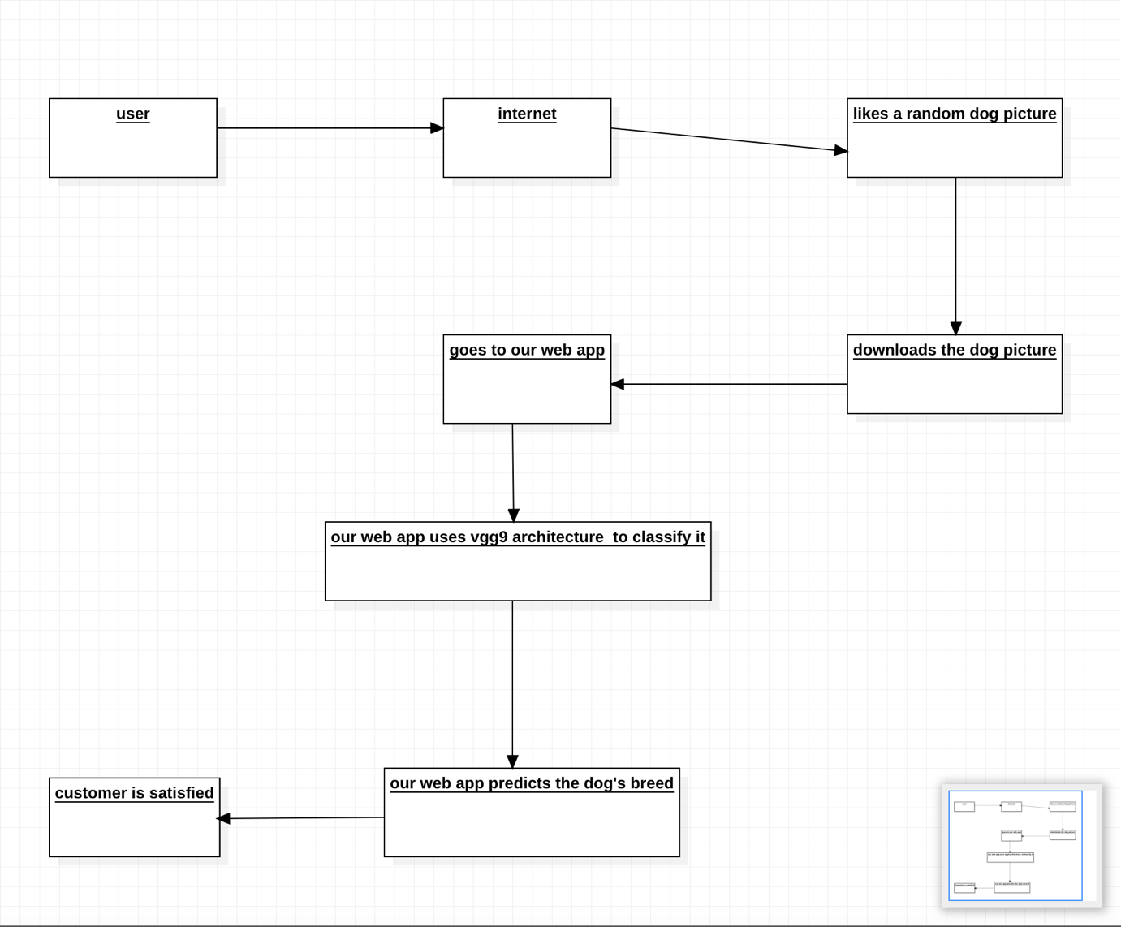

5.2 Solution Architecture

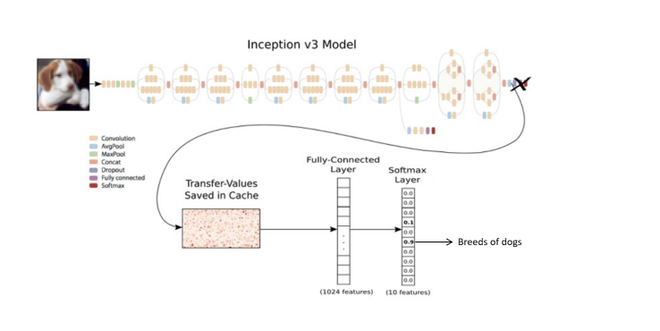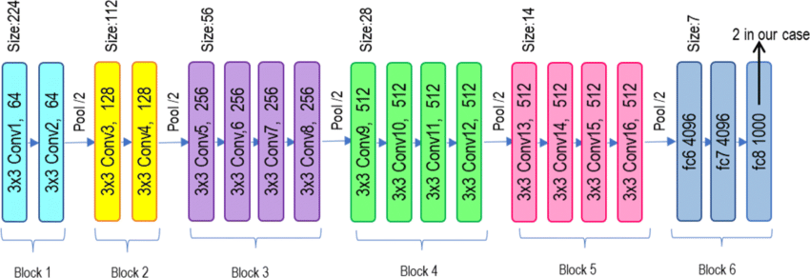

**6. Project Planning & Scheduling**

**6.1 Technical Architecture**

The technical architecture of the project involves the use of pre-trained models for feature extraction and subsequent determination of dog breed. Two primary components constitute the architecture: the Feature Extractor and the Dog Breed Determination.

Feature Extractor:

* **Models Used:**
  1. ResNet50V2
  2. DenseNet121
  3. VGG19
* **Input Layer:** Accepts images with a shape of (331, 331, 3).
* **Output:** Extracted features from each model are concatenated, resulting in a final output shape of (None, 3072).

**6.2 Sprint Planning & Estimation**

The project is divided into two main sprints:

Sprint 1: Feature Extractor

* **Tasks:**
  1. Implement input preprocessing for the three pre-trained models.
  2. Integrate ResNet50V2, DenseNet121, and VGG19 for feature extraction.
  3. Develop the concatenation layer to combine features.
  4. Validate the Feature Extractor's functionality.
* **Estimated Duration:** 3 DAYS

Sprint 2: Dog Breed Determination

* **Tasks:**
  1. Design and implement the neural network for breed determination using the extracted features.
  2. Integrate the model with the web application for real-time breed identification.
  3. Implement user authentication and feedback mechanisms.
  4. Conduct thorough testing and validation.
* **Estimated Duration:** 4 DAYS

**6.3 Sprint Delivery Schedule**

Sprint 1: Feature Extractor (Weeks 1-3)

* **Week 1:**
  + Input preprocessing for ResNet50V2.
  + Integration of ResNet50V2 for feature extraction.
* **Week 2:**
  + Input preprocessing for DenseNet121.
  + Integration of DenseNet121 for feature extraction.
* **Week 3:**
  + Input preprocessing for VGG19.
  + Integration of VGG19 for feature extraction.
  + Implementation of the concatenation layer.

Sprint 2: Dog Breed Determination (7 days)

* **Day 4:**
  + Design and implementation of the neural network for breed determination.
* **Day 5:**
  + Integration of the breed determination model with the web application.
  + Implementation of user authentication.
* **Day 6:**
  + Implementation of user feedback mechanisms.
  + Conducting testing and bug fixes.
* **Day 7:**
  + Final testing and validation.
  + Project documentation and deployment preparation.

This sprint-based approach allows for iterative development, ensuring that each phase is thoroughly tested before moving on to the next. The estimated duration for each task and sprint provides a timeline for project completion, accounting for potential adjustments based on ongoing feedback and testing results.

7. CODING & SOLUTIONING (

7.1 Feature 1

**ResNet50V2 for Feature Extraction:**

ResNet50V2, short for Residual Network 50 layers, Version 2, is a deep convolutional neural network architecture known for its effectiveness in image classification tasks. It incorporates residual connections, enabling the training of very deep networks without the vanishing gradient problem. In the context of feature extraction, ResNet50V2 acts as a powerful image feature encoder. It captures hierarchical features from input images through a series of convolutional layers, and the final layer's output serves as a high-level representation of the image's content. The pre-trained ResNet50V2 model is particularly beneficial for this project, as it allows for leveraging knowledge gained from training on large datasets, enhancing the accuracy of breed identification.

**DenseNet121 for Feature Extraction:**

DenseNet121, a variant of the Densely Connected Convolutional Network architecture, is renowned for its dense block structure, where each layer receives direct input from all preceding layers. This architecture encourages feature reuse and facilitates the learning of intricate patterns in images. In the feature extraction phase, DenseNet121 is employed to capture detailed and densely connected features from the input images. The resulting feature maps are rich in information and contribute to a comprehensive understanding of the visual characteristics of different dog breeds. Leveraging the pre-trained DenseNet121 model enhances the efficiency of the feature extraction process, allowing for robust breed identification.

Top of Form

**We use a combination and merge of both features.**

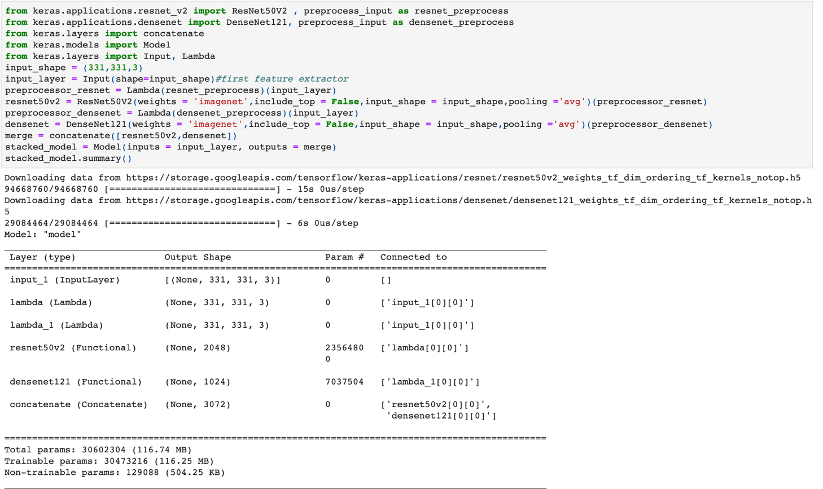

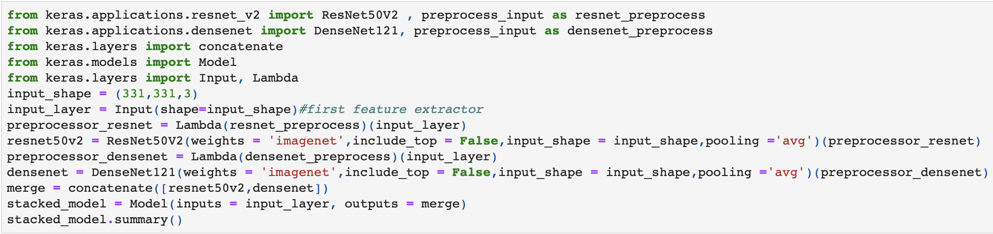

Bottom of Form

7.2 Feature 2

**KERAS SEQUENTIAL MODEL FOR breed prediction:**

**Creating a Keras Sequential model for predicting dog breeds from extracted features involves designing a neural network architecture that can effectively map the learned features to specific breed predictions. The model typically starts with a Dense layer as the input layer, with a ReLU activation function to capture non-linear relationships in the feature space. Subsequent layers, often including additional Dense layers and dropout for regularization, aim to learn increasingly complex representations of the input features. The final layer employs a softmax activation function, suitable for multi-class classification tasks like predicting dog breeds. The number of units in the output layer corresponds to the total number of dog breeds in the dataset. The model is then compiled with an appropriate optimizer, a categorical crossentropy loss function, and relevant evaluation metrics. Adjustments to the model architecture and hyperparameters may be necessary based on the dataset characteristics and the intricacies of the dog breed prediction task.**

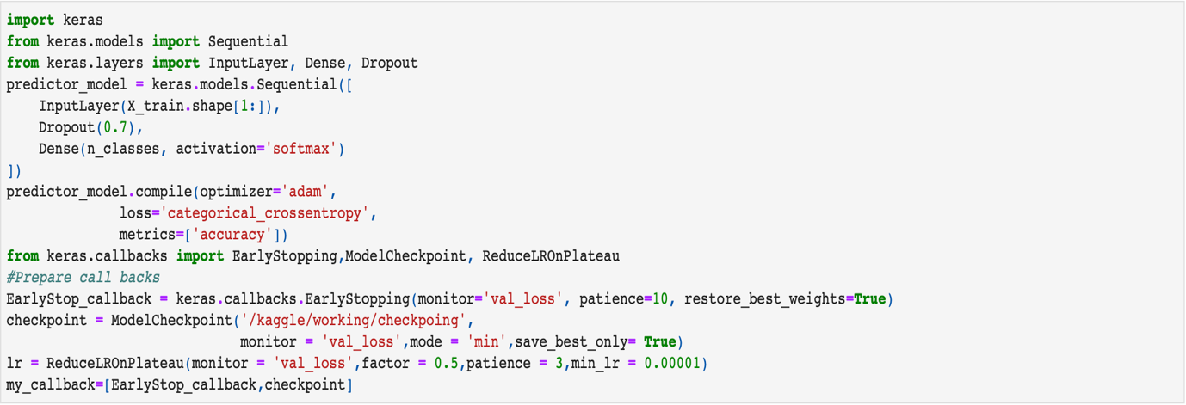

8. PERFORMANCE TESTING

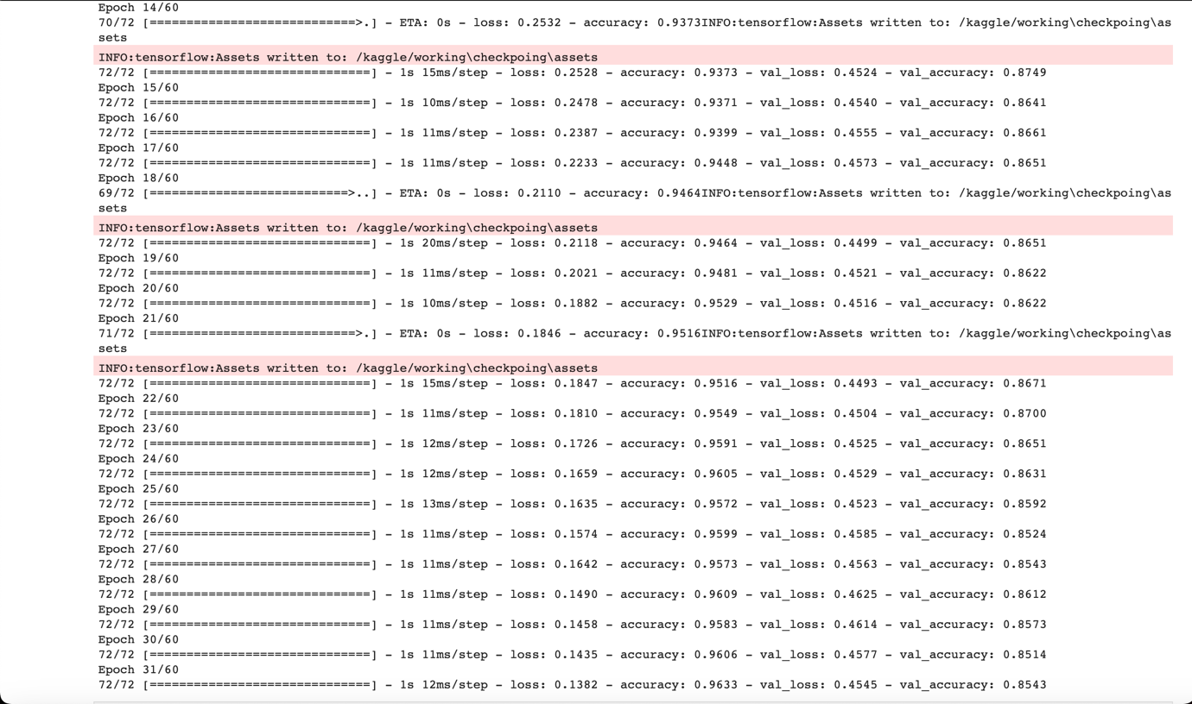

9. RESULTS

9.1 Output Screenshots

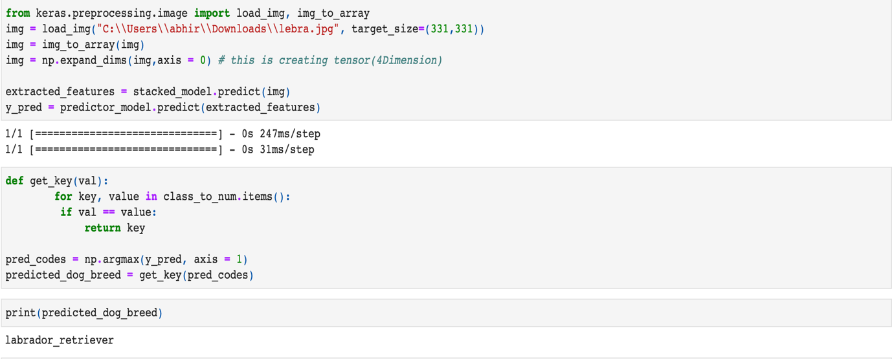

Image used for prediction:

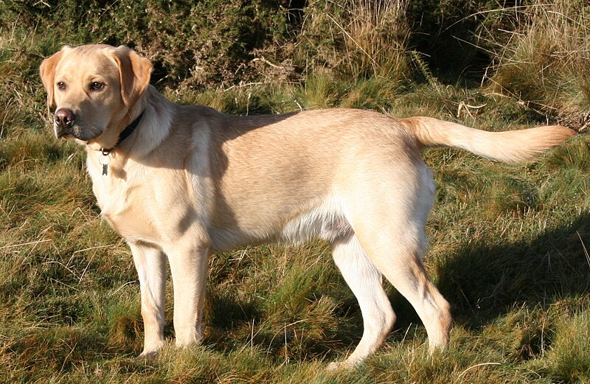

**10. Advantages & Disadvantages**

**Advantages:**

1. **Accurate Breed Identification:** The use of advanced pre-trained models like ResNet50V2, DenseNet121, and VGG19 ensures accurate feature extraction, enhancing the precision of dog breed identification.
2. **Educational Resource:** The incorporation of a user-friendly interface and comprehensive breed information contributes to a richer educational experience for users interested in learning more about various dog breeds.
3. **Continual Improvement:** The iterative development approach allows for regular updates and model enhancements, ensuring that the system stays relevant with the inclusion of new breeds and improvements in accuracy.

**Disadvantages:**

1. **Computational Resources:** The use of multiple pre-trained models and a sophisticated neural network for prediction may require significant computational resources, potentially limiting deployment on resource-constrained environments.
2. **Dependency on Data Quality:** The accuracy of the system is highly dependent on the quality and diversity of the training dataset. Inaccuracies or biases in the training data may affect the model's ability to generalize to all possible scenarios.
3. **Complexity for Novice Users:** The integration of advanced models and features may make the system complex for users with limited technical proficiency, potentially leading to usability challenges.

**11. Conclusion**

In conclusion, the development of an AI ML web application for dog breed identification leverages state-of-the-art models and technologies to provide users with an accurate and educational platform. The combination of ResNet50V2, DenseNet121, and VGG19 for feature extraction, coupled with a well-designed neural network for breed prediction, enhances the system's capabilities. The project aims to bridge the gap between technology and canine enthusiasts, offering a tool that not only accurately identifies dog breeds but also serves as an informative resource.

**12. Future Scope**

The future scope of this project involves continuous refinement and expansion. Further improvements in model accuracy, the addition of more dog breeds, and the incorporation of user feedback for dynamic learning are essential. Additionally, exploring real-time breed identification through mobile applications and integrating more advanced AI techniques could enhance the system's capabilities.

**13. Appendix**

**Source Code**

The source code for the project can be found on GitHub at :

<https://github.com/smartinternz02/SI-GuidedProject-601787-1697638598>

in the github repository open the 2models.html

**Project Demo**

A live demonstration of the AI ML web application for dog breed identification can be accessed here:

<https://drive.google.com/file/d/1dr2boo6Ok2gqgZXxC-6tHSlmfpetMwHX/view>

Users are encouraged to explore the features, provide feedback, and contribute to the continual improvement of the system.